LICEOR Cubesat Thermal Design and Engineering Analysis

Khushaldas Badhan, ISM 2021-22, University of Luxembourg

Cubesat Lab 2

# Introduction:

The thermal control subsystem in a spacecraft is responsible for maintaining temperature of various components in the spacecraft to operating/ functional, survival and optimum as required. This is achieved by either active control or using passive control. In active control, an electronic system is used to monitor temperature of the components in scope and active elements such as radiator louvers, heaters are used to actively modify heat flow across the spacecraft to change control the temperature. In passive thermal control system, though there can be active monitoring of temperature no action is taken to control the heat flow and the design of spacecraft is created such that the temperatures are maintained within the desired ranges. In comparison to the active control the passive control is much simpler in operation and can be much more reliable due to lack of any components which can fail. Below table shows the temperature requirements of various components in the LICEOR cubesat.

|  |  |  |
| --- | --- | --- |
| **Components** | **Min Operational** | **Max Operational** |
| Antenna | -20 | 60 |
| EPS | -20 | 60 |
| Antenna PNT | -40 | 85 |
| Battery | -10 | 80 |
| Solar Panels | -40 | 85 |
| ADCS | -10 | 60 |

For the LICEOR mission cubesat passive thermal control is designed. This is achieved by designing the spacecraft such that the total heat rejected by the spacecraft is equal to total heat gained therefore, maintaining the temperature. As there are some components which explicitly only generate heat and some components which only reject heat it is important that these components are connected by sufficient sized conduction and radiation elements. Design of passive thermal control system can be initiated by estimating amount of heat that will be gained and rejected by spacecraft. For this single node analysis can be used.

# Single Node Model:

Figure 1 shows single node thermal model for LICEOR cubesat.

Figure 1 Single Node Model of the LICEOR Cubesat

Below graph shows how temperature of a component affects heat rejected by it to the deep

Figure 2 Heat Rejection Rate to Space and Change in Temperature with respect to temperature of the body

space and expected decrease in temperature of it due to the rejected heat in 1 second[1]. As seen from this chart it can be said that high temperature of single surface does not cause significant temperature change in the spacecraft and hence localise temperature anomaly does not have significant impact on overall heat gained or rejected by the spacecraft. Hence, the single node model can provide insights on whether the spacecraft be overall heated or cooled without any active or passive interventions. With these insights thermal control system can be designed to mitigate the observed behaviour. For example, if it is observed that the total heat is gained by spacecraft then radiators can be added and connected to heat generating components to reject the generated heat to the deep space. Whereas if it is observed that overall heat is being rejected by the spacecraft then surface facing the sun or electric heater can be added to and connected to colder regions of the spacecraft. For deeper analysis and internal thermal design of the satellite multimode model is used. Next section describes implemented methodology of multimode analysis.

# Methodology:

For the thermal analysis the model for the satellite is divided into nodes. Each node can interact with the other. By interaction it means transmission of heat by conduction and radiation.

There are two types of nodes: 1) Heat Storage nodes and 2) Interface nodes

Heat Storage Node (HSN): These nodes represent actual discreet bulk masses in the satellite and store heat.

Interface Node (IFN): These nodes represent interfaces for the HSNs. HSNs have interaction with other HSNs through IFNs. Heat is exchanged by IFNs, and the summation of the total heat exchanged by all the IFNs associated to an HSN gives total heat gain/loss in an HSN.

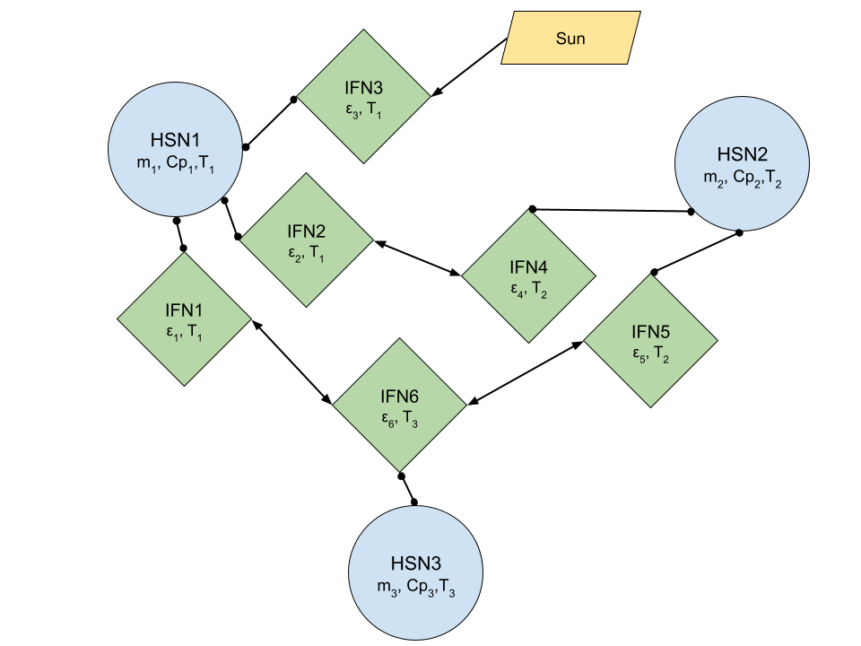

### Fig HSN and IFN interaction

For example, an HSN can be a wall panel of the satellite while IFNs for it are the inside face of the wall which exchanges heat with components inside the satellite and outside face of the wall which exchanges heat with elements outside the satellite for example, sun, Earth, deep space, etc. For the wall, total heat will be the summation of heat exchanged by both IFNs. Below is a list of the HSNs and IFNs in the LICEOR satellite thermal model.

|  |  |  |
| --- | --- | --- |
| **IFN Index** | **Name of the node** | **HSN Index** |
| 1 | ISIS Antenna rod Zenith | 1 |
| 2 | ISIS Antenna rod Nadir | 2 |
| 3 | ISIS Antenna rod Nadir right | 3 |
| 4 | ISIS Antenna rod Nadir left | 4 |
| 5 | ISIS Antenna P | 5 |
| 6 | ISIS Antenna N | 6 |
| 7 | counterweight | 7 |
| 8 | IOBC X+ | 8 |
| 9 | IOBC X- | 8 |
| 10 | SGR | 9 |
| 11 | ADCS X1 | 10 |
| 12 | ADCS X2 (magtorquer X axis) | 11 |
| 13 | ADCS X3 | 12 |
| 14 | ADCS X4 | 13 |
| 15 | ADCS X5 (magtorquer Y and Z axis) | 14 |
| 16 | EPS X1 (face near X+) | 15 |
| 17 | ISIS | 16 |
| 18 | Prop X1 | 17 |
| 19 | Prop X2 (side single surface as single node) | 17 |
| 20 | Prop X3 (nozzle) | 17 |
| 21 | Frame Vertical Nadir Left X1 | 18 |
| 22 | Frame Vertical Nadir Right X1 | 19 |
| 23 | Frame Vertical Nadir Left X2 | 20 |
| 24 | Frame Vertical Nadir Right X2 | 21 |
| 25 | Frame Vertical Zenith Right X1 | 22 |
| 26 | Frame Vertical Zenith Left X1 | 23 |
| 27 | Frame Vertical Zenith Right X2 | 24 |
| 28 | Frame Vertical Zenith Left X2 | 25 |
| 29 | Wall Nadir N | 26 |
| 30 | Wall Nadir Left N | 27 |
| 31 | Wall Nadir Right N | 28 |
| 32 | Wall Zenith N | 29 |
| 33 | Wall Nadir P | 26 |
| 34 | Wall Nadir Left P | 27 |
| 35 | Wall Nadir Right P | 28 |
| 36 | Wall Zenith P | 29 |
| 37 | SP Nadir X1 | 30 |
| 38 | SP Nadir X2 | 31 |
| 39 | SP Zenith X1 | 32 |
| 40 | SP Zenith X2 | 33 |
| 41 | SP Nadir Right X1 | 34 |
| 42 | SP Nadir Right X2 | 35 |
| 43 | SP Nadir Left X1 | 36 |
| 44 | SP Nadir Left X2 | 37 |
| 45 | GPS Rx Nadir | 38 |
| 46 | GPS Rx Zenith | 39 |
| 47 | EPS X2 (face away from X+) | 15 |
| 48 | EPS Nadir face | 15 |
| 49 | EPS Nadir right face | 15 |
| 50 | EPS Nadir left face | 15 |
| 51 | EPS Zenith face | 15 |
| 52 | EPS X3 (face on the X- side) | 15 |
| 53 | Prop X4 (flat face on the side of nozzle (not nozzle exit)) | 17 |

Below figures show HSNs in the cubesat:

## Fig Cubesat Model HSN 18-25

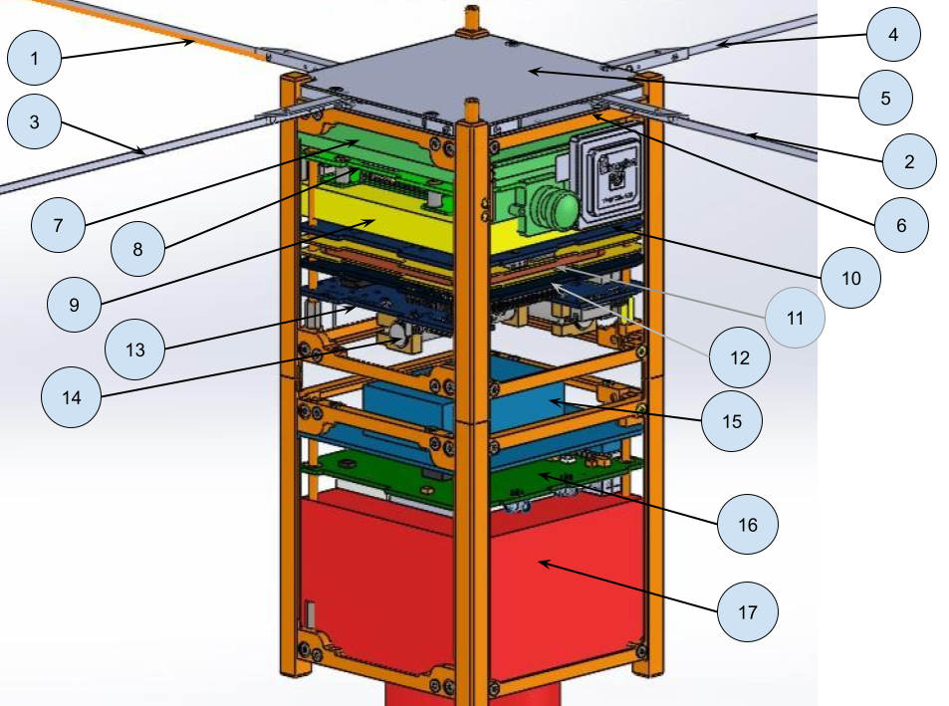

### Fig Cubesat Model HSN 1-17

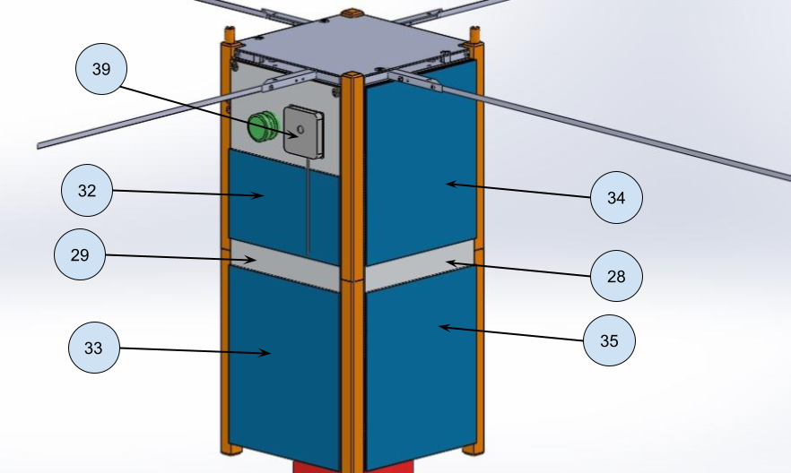

### Fig Cubesat Model HSN 28, 29, 33-35, 39

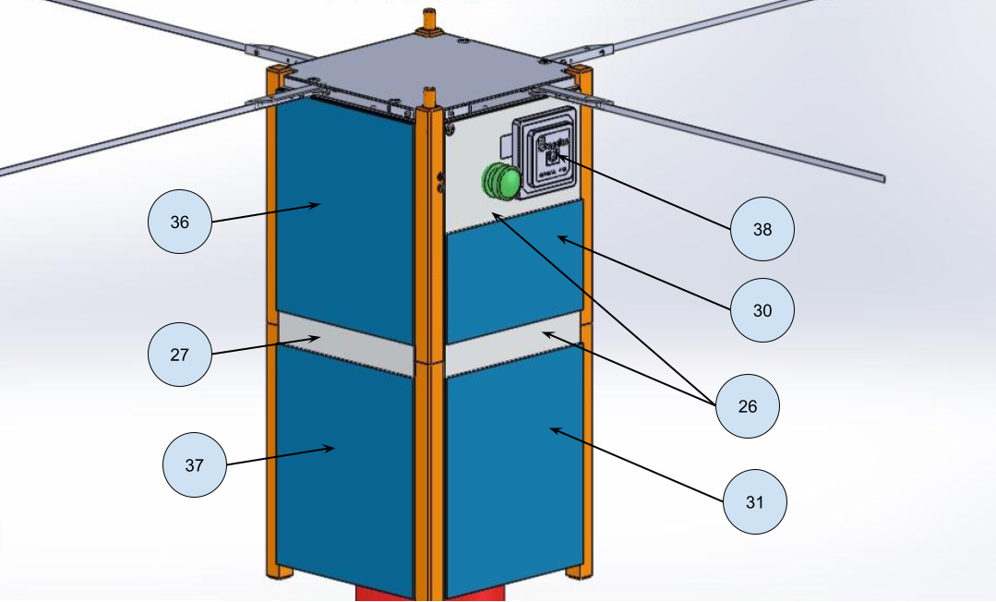

### Fig Cubesat Model HSN 26, 27, 30, 31, 36-39

Radiation heat exchange between two IFN indexed *i* and *j* is given by following formula:

Where,

Stefan–Boltzmann constant  
view factor from IFN i to IFN j

emissivity of respective IFN

temperatures of respective IFN

interface areas of respective IFN}

Conduction heat exchange between two IFN indexed *i* and *j* is given by following formula:

The heat received from sun by an IFN is given by:

Where,

sun elevation angle

The heat received from Earth emitted IR by an IFN is given by:

here,

access to Earth  
 absorptivity of IFN

emissivity of IFN I

per unit area Earth IR in orbit surface, J/m2

IR emitted by Earth at surface

surface area of orbit

surface area of Earth

Heat rejected to deep space by an IFN is given by:

Where,

access to space temperature of deep space = 3 K

Total heat exchange between two IFNs is the sum of heat exchanged by all methods. It can be written as:

The total heat exchange in an IFN is the sum of heat exchanged between the IFN and other IFNs and heat exchanged between external elements. Same is explained below:

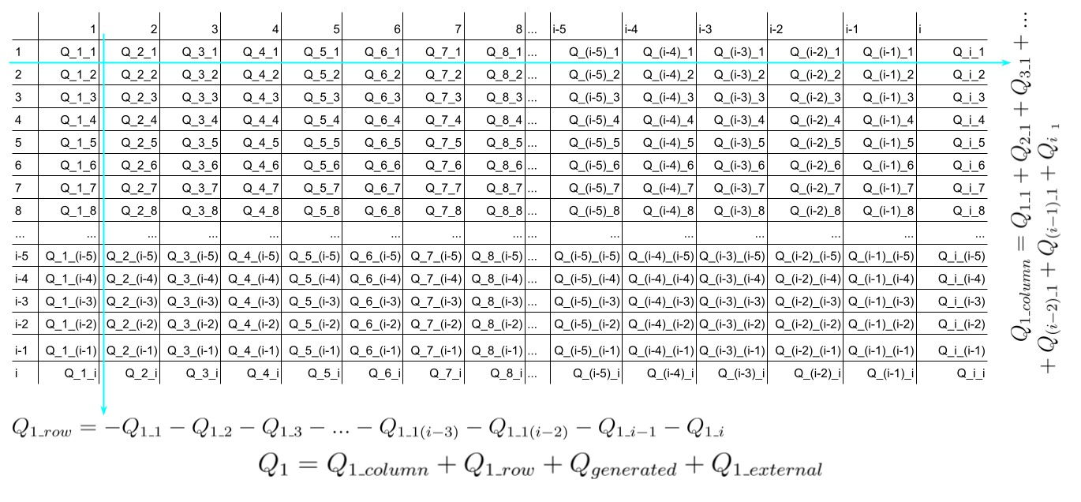

Here the Qi is total heat flow for IFNs, to calculate for HSNs we sum up the total heat flow of IFNs associated with that HSN. For example, for total heat flow from *Wall Nadir* i.e., HSN 26, we sum up heat flow in IFNs 29 and 33. The generalise form for total heat exchange from an HSN can be written as:

For example,

To calculate change in temperature, thermal inertia of the HSN is considered. The temperature of the HSN at any time step *t* can be given as:

The input data for the calculation is in a table or array format. Values of view factor, access, areas, emissivity, absorptivity, conductivity, cross-sectional areas and length of conducting elements, IFNs and HSNs association, masses, specific heat, heat generated, initial temperatures, sun elevation are input provided by user defined tables or arrays.

The view factor *Fij* for various IFNs were determined using empirical relationships as demonstrated using below charts.

Figure 3 View Factor Empirical Relationship 1

Figure 4 View Factor Empirical Relationship 2

# Process Flow in the code:

1. Time step size is set to 1 second
2. Values for Stefan–Boltzmann constant, solar irradiance, radius of Earth, altitude of orbit, total simulation time, temperature of space and temperature of Earth are defined
3. Values for Earth and orbit surface are calculated
4. Input datafiles in csv format are imported
5. Number of HSNs and IFNs is counted
6. Value of *Rij* is calculated using following loop
   1. First loop for *i*
      1. Set values associated with *i* from arrays
      2. Second loop for *j*
         1. Set values associated with *j* from arrays
         2. Calculate value of *Rij* using equation
         3. Store value of *Rij* in *Rij* array at row index of *j* and column index *i*
      3. Second loop complete
   2. First loop complete
7. Save *Rij* to csv file
8. Create array to store: net heat in IFNs, net heat in HSNs, temperature of IFNs, temperature of HSNs, net heat flow between node i and j, heat received from sun, heat rejected to space, initial temperature HSNs, radiation conduction and contact heat transfer between the node i and j
9. Loop for timestep
   1. Loop for IFNs at index *i* to calculate heat transfer from IFN *i* to IFN *j* with radiation, conduction and contact.
      1. Get value of *Rij* from corresponding array
      2. Get values of conductivity, length, cross-sectional area of conduction element between *i* and *j*
      3. Get values of temperature for *i* and *j* at corresponding timestep: if it is first timestep then value is the initial temperature. If the timestep is not first, then value is from previous timestep.
      4. Calculate heat exchange between *j* and *i* by conduction, contact and radiation and store the values in *QCond-ij*, *Qcont-ij*, *Qrad-ij* arrays at respective locations.
   2. Loop through all the IFNs for summation of heat transfer from each IFN across rows
      1. Assign values of *0* to heat transfer by conduction, contact and radiation for across row
      2. Loop through IFNs at index *k_row* for summation of heat transfer across rows.
         1. Retrieve value of *qcond-ik_row, qcont-ik_row, qrad-ik_row* from the arrays *QCond-ik_row*, *Qcont-ik_row*, *Qrad-ik_row.*
         2. Subtract the retrieved values from the assigned values in 8) b) i).
   3. Loop through all the IFNs for summation of heat transfer from each IFN across column
      1. Assign values of *0* to heat transfer by conduction, contact and radiation for across column
      2. Loop through IFNs at index *k_col* for summation of heat transfer across column.
         1. Retrieve value of *qcond-i**k_col, qcont-ik_col, qrad-ik_col* from the arrays *QCond-ik_col*, *Qcont-ik_col*, *Qrad-ik_col.*
         2. Add the retrieved values from the assigned values in 8) c) i).
      3. Get values for absorptivity, sun elevation, sun access, emissivity, area of sun interaction, Earth access, space access and HSN index corresponding to IFN index *i*
      4. Get value of temperature of IFN at index *i* from previous timestep or from initial temperature
      5. Calculate heat received from sun by IFN at index *i*
      6. Calculate heat received from Earth IR by IFN at index *i*
      7. Calculate heat flow between Earth and IFN at index *i*
      8. Calculate heat rejected to space by IFN at index *i*
      9. Calculate total heat flow from IFN at index *i*
      10. Add total heat flow from IFN at index *i* to corresponding HSN in the array at the timestep
   4. Loop through all the HSN for temperature calculation
      1. Add generated heat to the total heat flow from the HSN at the timestep in the array
      2. Get values of mass and specific heat of the HSN
      3. Calculate and add change in temperature of the HSN at the timestep
      4. Store the temperature values of the HSN in array
   5. Loop through all the IFNs for temperature assignment
      1. Get associated HSN number for the IFN
      2. Get temperature of the associated HSN and assign it to the IFN
      3. Store the IFN temperature in the respective array
10. Save the created arrays of net heat flow of IFN, net heat flow of HSN, Net heat flow between IFN *i* and *j*, temperature of IFN and temperature of HSN in csv files.

# Input Parameters:

Various input parameters used for the multimode model are described in this section. Below is list of mass for HSNs and emissivity for IFNs.

|  |  |
| --- | --- |
| **HSN Index** | **Mass in Kg** |
| 1 | 0.0014336 |
| 2 | 0.0014336 |
| 3 | 0.00408576 |
| 4 | 0.00408576 |
| 5 | 0.03448064 |
| 6 | 0.03448064 |
| 7 | 0.114 |
| 8 | 0.074 |
| 9 | 0.09 |
| 10 | 0.0375 |
| 11 | 0.0375 |
| 12 | 0.0375 |
| 13 | 0.0375 |
| 14 | 0.075 |
| 15 | 0.11 |
| 16 | 0.0375 |
| 17 | 0.435 |
| 18 | 0.022 |
| 19 | 0.022 |
| 20 | 0.022 |
| 21 | 0.022 |
| 22 | 0.022 |
| 23 | 0.022 |
| 24 | 0.022 |
| 25 | 0.022 |
| 26 | 0.065 |
| 27 | 0.065 |
| 28 | 0.065 |
| 29 | 0.065 |
| 30 | 0.024 |
| 31 | 0.024 |
| 32 | 0.024 |
| 33 | 0.024 |
| 34 | 0.024 |
| 35 | 0.024 |
| 36 | 0.024 |
| 37 | 0.024 |
| 38 | 0.02 |
| 39 | 0.02 |

|  |  |
| --- | --- |
| **HSN Index** | **Specific Heat J/KgK** |
| 1 | 380 |
| 2 | 380 |
| 3 | 380 |
| 4 | 380 |
| 5 | 380 |
| 6 | 380 |
| 7 | 890 |
| 8 | 380 |
| 9 | 380 |
| 10 | 380 |
| 11 | 380 |
| 12 | 380 |
| 13 | 380 |
| 14 | 380 |
| 15 | 890 |
| 16 | 380 |
| 17 | 890 |
| 18 | 890 |
| 19 | 890 |
| 20 | 890 |
| 21 | 890 |
| 22 | 890 |
| 23 | 890 |
| 24 | 890 |
| 25 | 890 |
| 26 | 890 |
| 27 | 890 |
| 28 | 890 |
| 29 | 890 |
| 30 | 1469 |
| 31 | 1469 |
| 32 | 1469 |
| 33 | 1469 |
| 34 | 1469 |
| 35 | 1469 |
| 36 | 1469 |
| 37 | 1469 |
| 38 | 380 |
| 39 | 380 |

|  |  |
| --- | --- |
| **IFN Index** | **Emissivity** |
| 1 | 0.8 |
| 2 | 0.8 |
| 3 | 0.8 |
| 4 | 0.8 |
| 5 | 0.8 |
| 6 | 0.03 |
| 7 | 0.1 |
| 8 | 0.89 |
| 9 | 0.89 |
| 10 | 0.89 |
| 11 | 0.89 |
| 12 | 0.03 |
| 13 | 0.89 |
| 14 | 0.89 |
| 15 | 0.03 |
| 16 | 0.8 |
| 17 | 0.89 |
| 18 | 0.1 |
| 19 | 0.1 |
| 20 | 0.1 |
| 21 | 0.1 |
| 22 | 0.1 |
| 23 | 0.1 |
| 24 | 0.1 |
| 25 | 0.1 |
| 26 | 0.1 |
| 27 | 0.1 |
| 28 | 0.1 |
| 29 | 0.1 |
| 30 | 0.1 |
| 31 | 0.1 |
| 32 | 0.1 |
| 33 | 0.1 |
| 34 | 0.1 |
| 35 | 0.1 |
| 36 | 0.1 |
| 37 | 0.88 |
| 38 | 0.88 |
| 39 | 0.88 |
| 40 | 0.88 |
| 41 | 0.88 |
| 42 | 0.88 |
| 43 | 0.88 |
| 44 | 0.88 |
| 45 | 0.1 |
| 46 | 0.1 |
| 47 | 0.8 |
| 48 | 0.8 |
| 49 | 0.8 |
| 50 | 0.8 |
| 51 | 0.8 |
| 52 | 0.8 |
| 53 | 0.1 |

|  |  |
| --- | --- |
| **IFN Index** | **Absorptivity** |
| 1 | 0.71 |
| 2 | 0.71 |
| 3 | 0.71 |
| 4 | 0.71 |
| 5 | 0.71 |
| 6 | 0.18 |
| 7 | 0.1 |
| 8 | 0.75 |
| 9 | 0.75 |
| 10 | 0.75 |
| 11 | 0.75 |
| 12 | 0.18 |
| 13 | 0.75 |
| 14 | 0.75 |
| 15 | 0.18 |
| 16 | 0.18 |
| 17 | 0.75 |
| 18 | 0.1 |
| 19 | 0.1 |
| 20 | 0.1 |
| 21 | 0.1 |
| 22 | 0.1 |
| 23 | 0.1 |
| 24 | 0.1 |
| 25 | 0.1 |
| 26 | 0.1 |
| 27 | 0.1 |
| 28 | 0.1 |
| 29 | 0.1 |
| 30 | 0.1 |
| 31 | 0.1 |
| 32 | 0.1 |
| 33 | 0.1 |
| 34 | 0.1 |
| 35 | 0.1 |
| 36 | 0.1 |
| 37 | 0.75 |
| 38 | 0.75 |
| 39 | 0.75 |
| 40 | 0.75 |
| 41 | 0.75 |
| 42 | 0.75 |
| 43 | 0.75 |
| 44 | 0.75 |
| 45 | 0.1 |
| 46 | 0.1 |
| 47 | 0.18 |
| 48 | 0.18 |
| 49 | 0.18 |
| 50 | 0.18 |
| 51 | 0.18 |
| 52 | 0.18 |
| 53 | 0.1 |

# Results:

Below figure 5 shows temperature variation of the selected nodes over period of three hours. The selected nodes are OBC (onboard computer), Y and Z axis of magnetorquer, Wall Nadir Left (wall panel facing deep space), Wall Nadir Right (wall panel facing sun).

Figure 5 Temperature Variation in selected nodes

Below figure 6 shows net heat in selected nodes over period of three hours. The spikes in the net heat are during firing of the thruster.

Figure 6 Net Heat in selected nodes

# Conclusion:

From the above results it can be concluded that the LICEOR cubesat is feasible for the mission. However, a longer duration analysis must be done to check thermal stability. It is also recommended to conduct a more detail analysis with assignment of IFNs and HSNs on important elements on the various PCBs such as ICs.

# References:

1. Mike-Alec Kearney, A thermal simulation tool for CubeSats for dynamic in-orbit scenarios, verified with flight data from the nSight-1 mission, 2020
2. Katelyn Elizabeth Boushon, Thermal analysis and control of small satellites in low Earth orbit, 2018
3. Howell, J.R., A catalog of radiation configuration factors, McGraw-Hill, 1982
4. Siegel, R., Howell, J.R., Thermal Radiation Heat Transfer, Taylor & Francis, 2002
5. Yang L, Li Q, Kong L, Gu S, Zhang L. Quasi-All-Passive Thermal Control System Design and On-Orbit Validation of Luojia 1-01 Satellite, 2019

1. The emissivity of the surface is assumed to be 0.8, temperature of the deep space is assumed to be 3 K, area of the surface is assumed to be 0.0025 m2, mass of the component is assumed to be 10 g, specific heat of the material is assumed to be 385 J/kgK.